Body parts in English
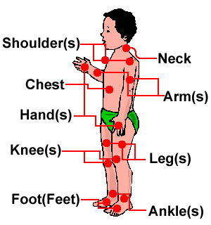
Available at: http://www.google.com.br/imgres?imgurl=http://www.learnenglish.de/imagesnew/vocab/body/bodyfront.gif&imgrefurl=http://www.learnenglish.de/vocabulary/body.htm&h=320&w=300&sz=8&tbnid=uRwmoRVPzSJG0M:&tbnh=118&tbnw=111&prev=/images%3Fq%3Dbody%2Bparts%2Bin%2Benglish&zoom=1&q=body+parts+in+english&hl=pt-BR&usg=__PHdOM1Hg57qjzt7zK-l0hPPHIo=&sa=X&ei=l9bqTMjiKMys8AaM1uDUCQ&ved =0CCQQ9QEwBQ on 11/22/2010.

