Head parts in English

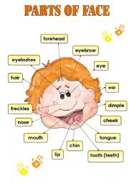

Available at:: http://www.google.com.br/imgres?imgurl=http://www.eslprintables.com/previewprintables/2009/feb/13/thumb902132125046406.jpg&imgrefurl=http://www.eslprintables.com/printable.asp%3Fid%3D179538&usg=__gWD90ehGmHyrP1etiyN8z4taTac=&h=256&w=180&sz=12&hl=pt-br&start=2&zoom=1&tbnid=UUpgFtzESG-k9M:&tbnh=111&tbnw=78&prev=/images%3Fq%3D%2522face%2Bparts%2Bin%2BEnglish%2522%26um%3D1%26hl%3Dpt-br%26sa%3DG%26biw%3D1346%26bih%3D583%26tbs%3Disch:1&um=1&itbs=1
on 11/22/2010.

